**Assignment 4**

**2. (5 points) Consider the network below.**

**a. Show the forwarding table in router A, such that all traffic destined to host H3 is forwarded through interface 3.**

Ans: Forwarding Table

| **Destination Address** | **Link Interface** |
| --- | --- |
| H3 | 3 |

**b. Can you write a forwarding table in router A, such that all traffic from H1 destined to host H3 is forwarded through interface 3, while all traffic from H2 destined to host H3 is forwarded through interface 4?**

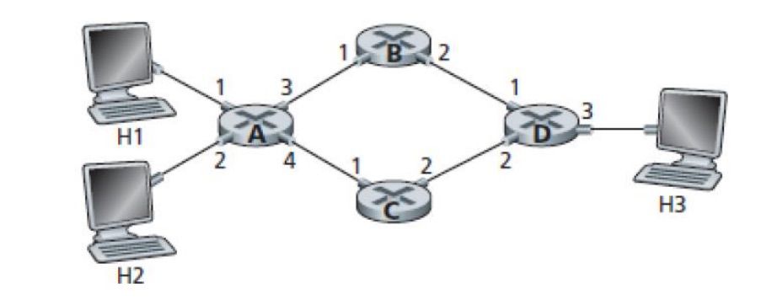

Ans: We can *not* create forwarding table in router **A** where *all* traffic from H1 to H3 is forwarded through interface 3, while all traffic from H2 destined to host H3 is forwarded through interface 4.

**3. (15 points) Consider the network setup in Figure 4.25 (see below). Suppose that the ISP instead assigns the router the address 24.34.112.235 and that the network address of the home network is 192.168.1/24.**

**a. Assign addresses to all interfaces in the home network.**

Ans: For Home network the addresses will be: *192.168.1.1*, *192.168.1.2*, *192.168.1.3* with the router Interface *192.168.1.4*

**b. Suppose each host has two ongoing TCP connections, all to port 80 at host 128.119.40.86, Provide the six corresponding entries in the NAT translation table.**

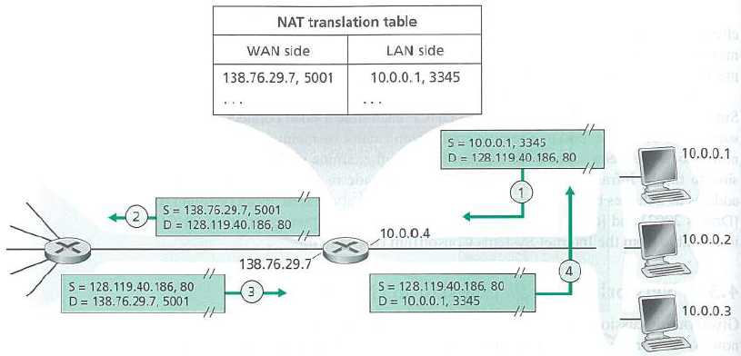

Ans: NAT Translation table

| **WAN** | **LAN** |
| --- | --- |
| 24.34.112.235, 4000 | 192.168.1.1, 3345 |
| 24.34.112.235, 4001 | 192.168.1.1, 3346 |
| 24.34.112.235, 4002 | 192.168.1.2, 3445 |
| 24.34.112.235, 4003 | 192.168.1.2, 3446 |
| 24.34.112.235, 4004 | 192.168.1.3, 3545 |
| 24.34.112.235, 4005 | 192.168.1.3, 3546 |

**4. (15 points) Consider a datagram network using 32-bit host addresses. Suppose a router has four links, numbered 0 through 3, and packets are to be forwarded to the link interfaces as follows:**

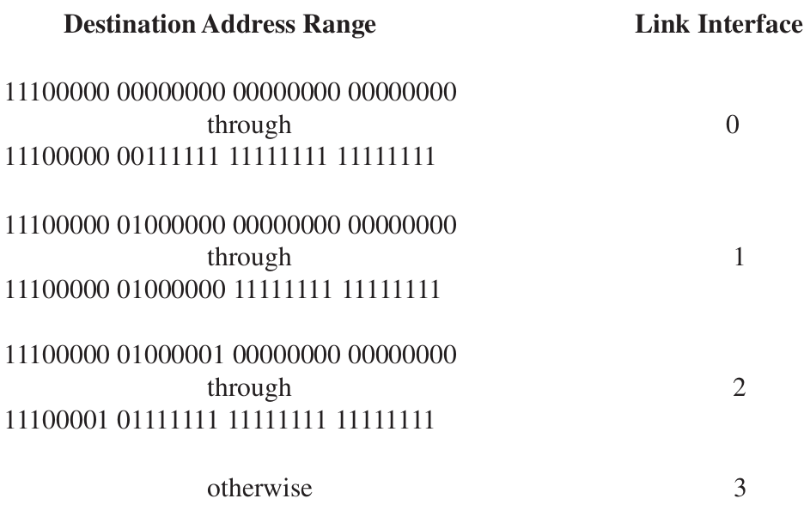

**a. Provide a forwarding table that has five entries, uses longest prefix matching, and forwards packets to the correct link interfaces.**

Ans: Forwarding Table

| **Destination Address Range** | **Link Interface** |
| --- | --- |
| 11100000 | 0 |
| 11100001 00000000 | 1 |
| 11100001 | 2 |
| otherwise | 3 |

**b. Describe how your forwarding table determines the appropriate link interface for datagrams with destination addresses:**

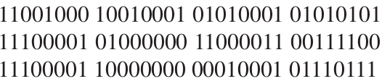

Ans: From the table given above,

| **Destination Address** | **Link Interface** |
| --- | --- |
| 11001000 10010001 01010001 01010101 | 3 |
| 11100001 01000000 11000011 00111100 | 1 |
| 11100001 10000000 00010001 01110111 | 2 |

**5. (15 points) Consider a router that interconnects three subnets: Subnet 1, Subnet 2, and Subnet 3. Suppose all of the interfaces in each of these three subnets are required to have the prefix 223.1.17/24. Also suppose that Subnet 1 is required to support at least 60 interfaces, Subnet 2 is to support at leas t 90 interfaces, and Subnet 3 is to support at least 12 interfaces. Provide three network addresses (of the form a.b.c.d/x) that satisfy these constraints**

Ans:

**Subnet 1** requires,

60 interfaces + 2 * (network + broadcast) => 64 addresses

**Subnet 2** requires,

90 interfaces + 2 * (network + broadcast) => 128 addresses

**Subnet 3** requires,

12 interfaces + 2 * (network + broadcast) => 16 addresses

Network Addresses that satisfy these constraints are:

**Sub 2:** 230.1.17.0/25 🡪 223.1.17.00000000/25 🡪 223.1.17.0 to 223.1.17.127 = 128

**Sub 1:** 230.1.17.128/26 🡪 223.1.17.10000000/26 🡪 223.1.17.128 to 223.1.17.191 = 64

**Sub 3:** 230.1.17.192/28 🡪 223.1.17.11000000/28 🡪 223.1.17.192 to 223.1.17.207 = 16

**6. (15 points) Consider the following network. With the indicated link costs, use Dijkstra’s shortest path algorithm to compute the shortest path from x to all network nodes. Show how the algorithm works by computing a table similar to Table 5.1 (Table 4.3 in 6th edition).**

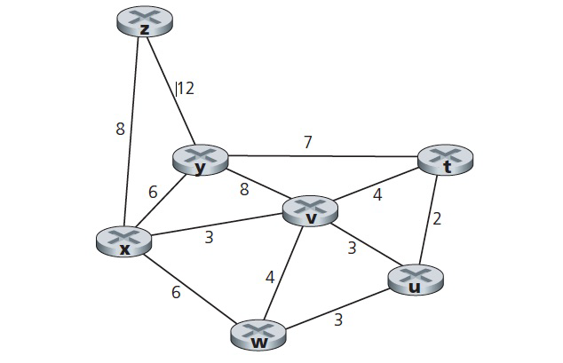

Ans:

| **Step** | **N’** | **D(t), p(t)** | **D(u), p(u)** | **D(v), p(v)** | **D(w), p(w)** | **D(y), p(y)** | **D(z), p(z)** |
| --- | --- | --- | --- | --- | --- | --- | --- |
| 0 | x | ∞ | ∞ | 3, x | 6, x | 6, x | 8, x |
| 1 | xv | 7, v | 6, v | 3, x | 6, x | 6, x | 8, x |
| 2 | xvu | 7, v | 6, v | 3, x | 6, x | 6, x | 8, x |
| 3 | xvuw | 7, v | 6, v | 3, x | 6, x | 6, x | 8, x |
| 4 | xvuwy | 7, v | 6, v | 3, x | 6, x | 6, x | 8, x |
| 5 | xvuwyt | 7, v | 6, v | 3, x | 6, x | 6, x | 8, x |
| 6 | xvuwytz | 7, v | 6, v | 3, x | 6, x | 6, x | 8, x |

**7. (10 points) Consider the network shown below. Suppose AS3 and AS2 are running OSPF for their intra-AS routing protocol. Suppose AS1 and AS4 are running RIP for their intra-AS routing protocol. Suppose eBGP and iBGP are used for the inter-AS routing protocol. Initially suppose there is no physical link between AS2 and AS4.**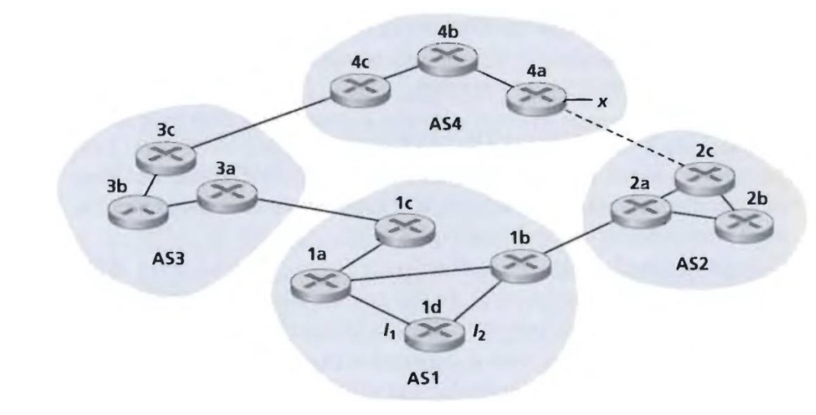

**a. Router 3c learns about prefix x from which routing protocol: OSPF, RIP, eBGP, or iBGP?**

Ans: eBGP

**b. Router 3a learns about x from which routing protocol?**

Ans: iBGP

**c. Router 1c learns about x from which routing protocol?**

Ans: eBGP

**d. Router 1d learns about x from which routing protocol?**

Ans: iBGP